BUDS HANDCRAFTED HELMET MIRRORS
A LOUISVILLE PRODUCT MADE FROM RECYCLED BICYCLE SPOKES
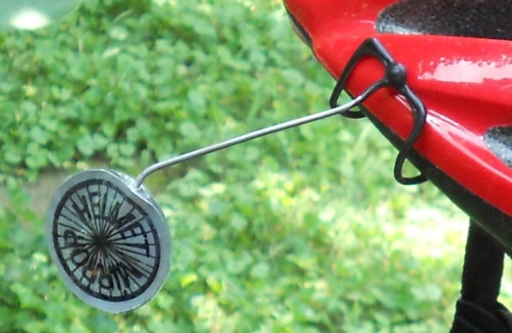
SEE OUR “HOW TO” VIDEOS ON YOUTUBE: Buds Helmet Mirrors
Attach the claw to helmet. Adjust by bending metal spoke using a pair of pliers or strong fingers. DO NOT attempt to bend the spoke by holding the mirror, as it can break the mirror. Proper adjustment: you should be able to see your finger on your ear and see a car behind you without turning your head, but simply shifting your eye. If the mirror becomes too loose, screw it in GENTLY, a little more (one turn), or unscrew it a few turns and put a small drop of Elmer’s or similar glue on the threads, screw it back together and let dry before using again. If you screw it down too far, it can separate and delaminate. This mirror should last several seasons with proper care.
This mirror is guaranteed not to desilver, or delaminate, for 90 days after purchase with registration. Please send an e-mail to: budshelmetmirrors@insightbb.com.
This glass mirror is breakable, and not intended for children’s use. Do not drop, or step on!

BUDS HANDCRAFTED HELMET MIRRORS
A LOUISVILLE PRODUCT MADE FROM RECYCLED BICYCLE SPOKES
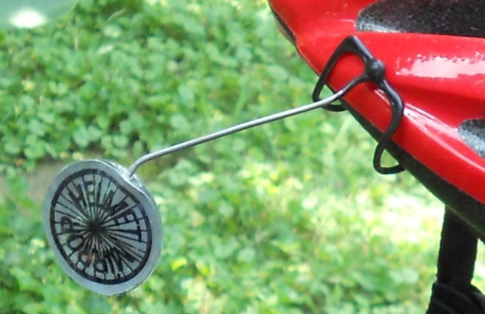
SEE OUR “HOW TO” VIDEOS ON YOUTUBE: Buds Helmet Mirrors
Attach the claw to helmet. Adjust by bending metal spoke using a pair of pliers or strong fingers. DO NOT attempt to bend the spoke by holding the mirror, as it can break the mirror. Proper adjustment: you should be able to see your finger on your ear and see a car behind you without turning your head, but simply shifting your eye. If the mirror becomes too loose, screw it in GENTLY, a little more (one turn), or unscrew it a few turns and put a small drop of Elmer’s or similar glue on the threads, screw it back together and let dry before using again. If you screw it down too far, it can separate and delaminate. This mirror should last several seasons with proper care.
This mirror is guaranteed not to desilver, or delaminate, for 90 days after purchase with registration. Please send an e-mail to: budshelmetmirrors@insightbb.com.
This glass mirror is breakable, and not intended for children’s use. Do not drop, or step on!

